# 

Contents

Topic 1-PowerBI Overview and Installation 2

1. Basic Usage 2

a. What is it 2

b. What it is used for 2

c. Why it’s needed 2

d. Basic Example 2

e. Real World Example 3

f. Scenario 3

g. Data Set 3

2. Installation of PowerBI DeskTop 3

a. PowerBI DeskTop 3

b. Installation (Class exercise) 4

Minimum requirements 5

c. Video 6

Topic 2 6

1. Basic Usage 6

a. What is it 6

2. Class Exercise 6

a. Scenario 6

b. Data Set 7

c. 7

3. Video 7

Topic 1-PowerBI Overview and Installation

1. Basic Usage – Used to create interactive reports and dashbaords

### What is it

**Power BI** is a cloud-based business analytics service that enables anyone to visualize and analyze data with greater speed, efficiency, and understanding.

### What it is used for

It connects users to a broad range of data through easy-to-use dashboards, interactive reports, and compelling visualizations that bring data to life.

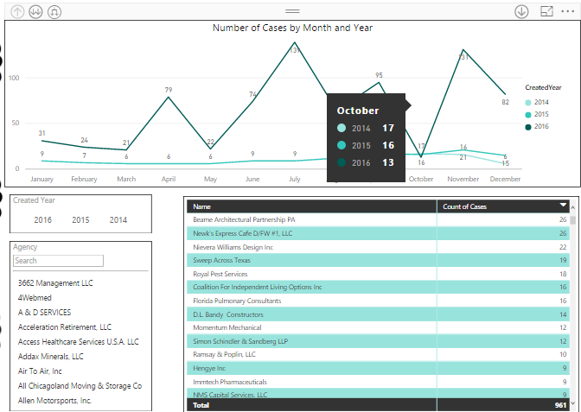

### Why it’s needed

Microsoft **Power BI** is a free, self-service business intelligence cloud service that provides non-technical business users with tools for aggregating, analyzing, visualizing and sharing data.

### Basic Example

Power BI is intended for small to mid-size business owners looking to add reporting tools to non- technical users. Resources can be found at PowerBI.com that provides installation, report creation, sharing, and other learning material that promotes further education. Those who have worked with Excel can implement some of the same features in create mobile reports and dashboards that can easily be shared.

* 1. Real World Example – Shaddy Outlaw Used Cars is looking to add business intelligence to the company. Due to costs and other BI tools being to expensive the decision has been made to use PowerBI.
  2. Scenario – The business needs reporting done on the number of sales each month by vehicle type, number of sales each month by SalesRep, and additional information that will help grow the business.
  3. Data Set – All the data about the business has been stored in Excel spreadsheets for the past couple of years and will continue to do so in the future.

1. Installation of PowerBI DeskTop

### PowerBI DeskTop

Microsoft Power BI Desktop is a companion desktop application to [Power BI](http://go.microsoft.com/fwlink/?LinkID=522474).

Note: Power BI only works with educational and organizational emails.  
See here: <https://docs.microsoft.com/en-us/power-bi/service-self-service-signup-for-power-bi>  
  
Here is a work around from Guy in A Cube: <https://docs.microsoft.com/en-us/power-bi/service-admin-signing-up-for-power-bi-with-a-new-office-365-trial>  
  
With Power BI Desktop, you can:

* + - Get data
      * The Power BI Desktop makes discovering data easy. You can import data from a wide variety of data sources. After you connect to a data source, you can shape the data to match your analysis and reporting needs.
    - Create relationships and enrich your data model with new measures and data formats
      * When you import two or more tables, oftentimes you'll need to create relationships between those tables. The Power BI Desktop includes the Manage Relationships dialog and the Relationships view, where you can use Autodetect to let the Power BI Desktop
      * find and create any relationships, or you can create them yourself. You can also very easily create your own measures and calculations or customize data formats and categories to enrich your data for additional insights.
    - Create reports
      * The Power BI Desktop includes the Report View. Select the fields you want, add filters, choose from dozens of visualizations, format your reports with custom colors, gradients and several other options. The Report View gives you the same great report and visualizations tools just like when creating a report on PowerBI.com.
* Save your reports

With the Power BI Desktop, you can save your work as a Power BI Desktop file. Power BI Desktop files have a .pbix extension.

* + - Upload or Publish your reports

You can upload the reports you created and saved in the Desktop to your Power BI site. You can also publish them to Power BI right from Power BI Desktop.

### Installation (Class exercise)

You can download the latest version of Power BI Desktop from the following download page:

* [**Power BI Desktop download** (both 32- and 64-bit versions)](https://powerbi.microsoft.com/desktop).

Regardless of which way you choose to download, once **Power BI Desktop** is downloaded you're prompted to run the installation file:

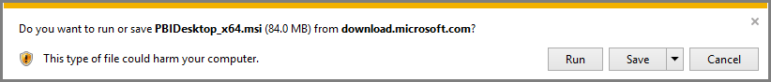

**Power BI Desktop** is installed as an application, and runs on your desktop.

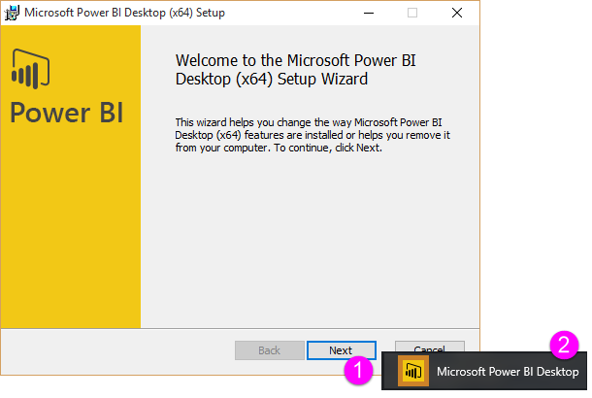

When you launch **Power BI Desktop**, a Welcome screen is displayed.

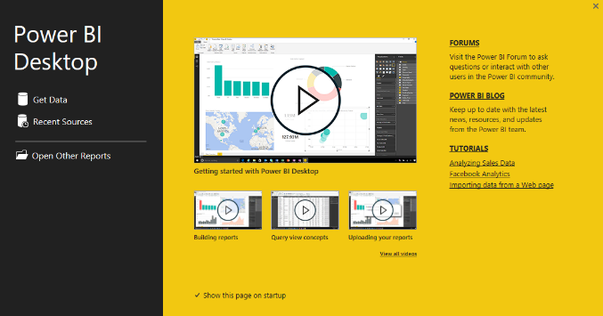

From there, you can begin creating data models or reports, then share them with others on the Power BI service. Check out the **More information** links at the end of this article for links to guides that can help you get started using **Power BI Desktop**.

## **Minimum requirements**

The following list provides the minimum requirements to run **Power BI Desktop**:

Windows 7 / Windows Server 2008 R2, or later, .NET 4.5, Internet Explorer 9 or later

**Memory (RAM):** At least 1 GB available, 1.5 GB or more recommended.

* 1. Video

Topic 2 – Get data and Working with Query Editor

1. Basic Usage

With Power BI Desktop installed you’re ready to connect to data, shape data, and build reports (usually in that order). There are all sorts of data sources available in the Query window.

### What is it

**Query Editor**, a powerful tool for shaping and transforming data so it's ready for your models and visualizations. When you select Edit from Navigator, Query Editor launches and is populated with the tables or other entities you selected from your data source.

You can also launch **Query Editor** directly from **Power BI Desktop**, using the **Edit Queries** button on the **Home** ribbon.

1. Class Exercise
   1. Scenario – This month’s sales data just came in. Using this as a source, connect to the data and use Query Editor to make the proper adjustments

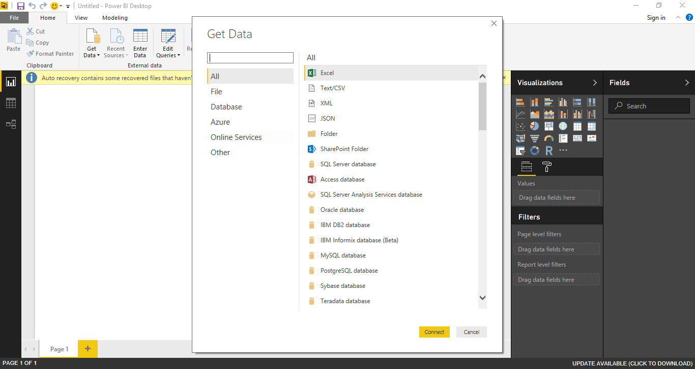

b. Data Set

Excel file called **CarSalesData.xlsx**

(One Drive Link - <https://1drv.ms/x/s!AgsRLppxitDjgRzJysEIxrqEQ3oy>)

c.

Once Query Editor is loaded with data that's ready for you to shape, you see a handful of sections:

1. In the ribbon, many buttons are now active to interact with the data in the query
2. In the left pane, queries (one for each table, or entity) are listed and available for selection, viewing, and shaping
3. In the center pane, data from the selected query is displayed and available for shaping
4. The Query Settings window appears, listing the query’s properties and applied steps

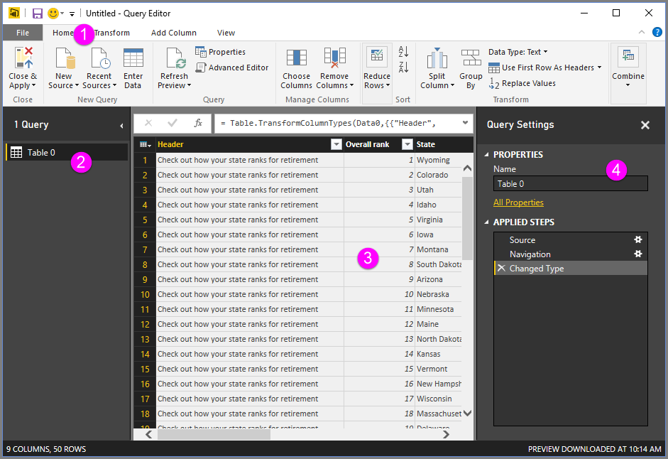

## Video